國立中興大學資訊科學與工程學系碩士學位論文

使用串級深度學習網路於即時 PVC 皮革表面瑕疵偵測之研究

A New Real-Time Defect Detection Method for The PVC Leather Surface

Using Cascaded Deep Learning Neural Networks

指導教授：吳俊霖 Jiunn-Lin Wu

研 究 生：張立 Li Chang

中華民國 一一○ 年 八 月



A New Real-Time Defect Detection Method for The PVC Leather Surface Using Cascaded Deep Learning Neural Networks

 ikn  710805607 l

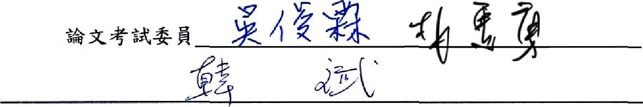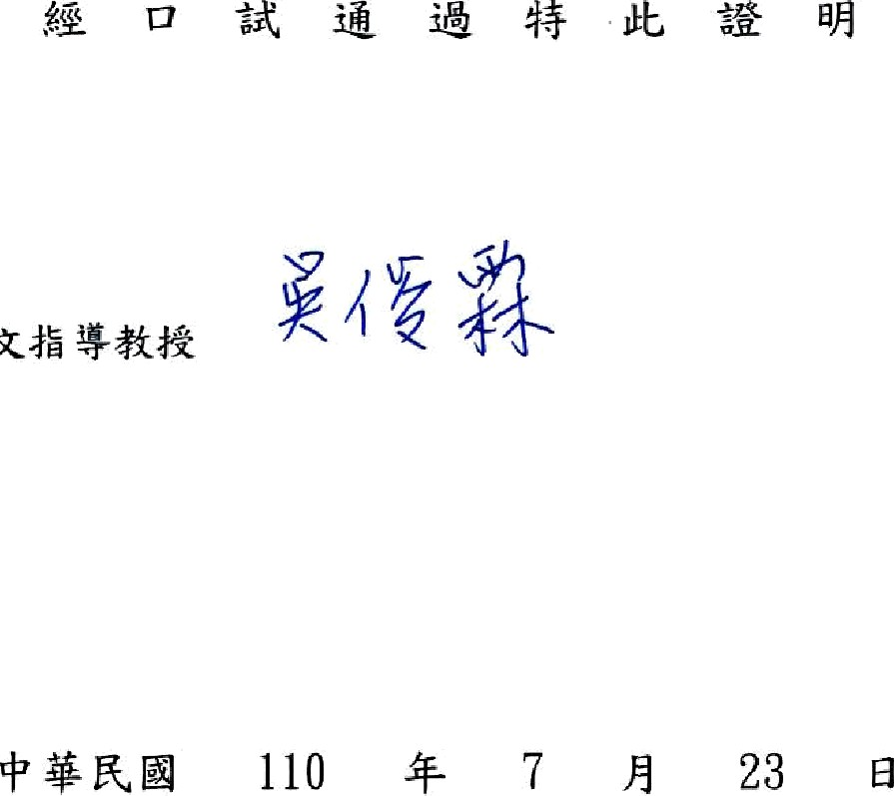



Only two pages were converted.

Please **Sign Up** to convert the full document.

[**www.freepdfconvert.com/membership**](https://www.freepdfconvert.com/membership)